4.1. Design and Analysis of an FIR Low-Pass Filter Using the Rectangular Window Technique in MATLAB.

CODING:
clc;
clear;
close all;

%% --- Input Parameters ---
fp = 1000; % Passband cutoff (Hz)
fs = 4000; % Sampling frequency (Hz)
N = 50; % Filter order (even number preferred)

wc = fp/(fs/2); % Normalized cutoff frequency (0 to 1)

%% --- 1. FIR Low Pass using Rectangular Window ---
b_rect = fir1(N, wc, 'low', rectwin(N+1));
disp('--- Rectangular Window Coefficients ---');
disp(b_rect');

%% --- 2. FIR Low Pass using Hamming Window ---
b_hamm = fir1(N, wc, 'low', hamming(N+1));
disp('--- Hamming Window Coefficients ---');
disp(b_hamm');

%% --- 3. FIR Low Pass using Hanning Window ---
b_hann = fir1(N, wc, 'low', hanning(N+1));
disp('--- Hanning Window Coefficients ---');
disp(b_hann');

%% --- Plot Frequency Responses ---
figure;
freqz(b_rect,1);
title('Low-pass FIR using Rectangular Window');

figure;
freqz(b_hamm,1);
title('Low-pass FIR using Hamming Window');

figure;
freqz(b_hann,1);
title('Low-pass FIR using Hanning Window');

OUTPUT: 1
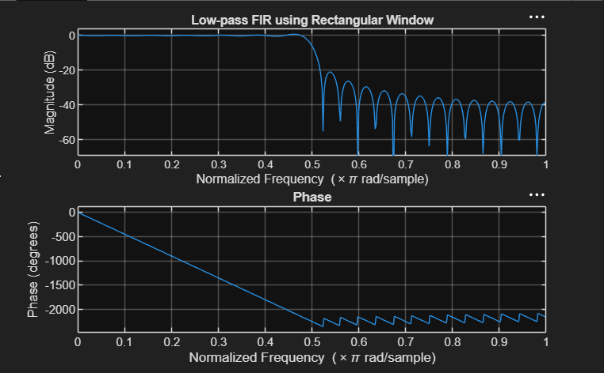

OUTPUT: 2
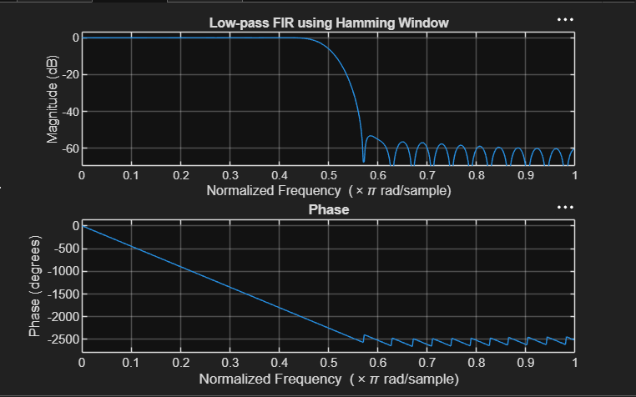

OUTPUT: 3
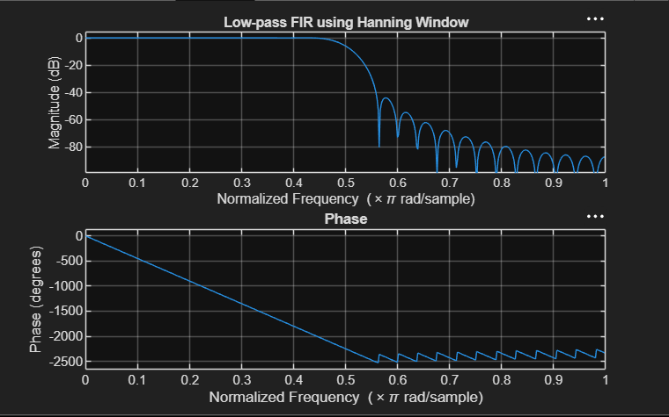

RESULT:
Rectangular Window Coefficients ---
0.0126
0
-0.0137
0
0.0150
0
-0.0166
0
0.0185
0
-0.0210
0
0.0242
0
-0.0286
0
0.0349
0
-0.0449
0
0.0629
0
-0.1048
0
0.3145
0.4940
0.3145
0
-0.1048
0
0.0629
0
-0.0449
0
0.0349
0
-0.0286
0
0.0242
0
-0.0210
0
0.0185
0
-0.0166
0
0.0150
0
-0.0137
0
0.0126
--- Hamming Window Coefficients ---
0.0010
0
-0.0013
0
0.0021
0
-0.0034
0
0.0055
0
-0.0084
0
0.0125
0
-0.0181
0
0.0260
0
-0.0379
0
0.0580
0
-0.1026
0
0.3168
0.4995
0.3168
0
-0.1026
0
0.0580
0
-0.0379
0
0.0260
0
-0.0181
0
0.0125
0
-0.0084
0
0.0055
0
-0.0034
0
0.0021
0
-0.0013
0
0.0010

--- Hanning Window Coefficients ---
0.0000
0
-0.0004
0
0.0013
0
-0.0028
0
0.0050
0
-0.0081
0
0.0122
0
-0.0179
0
0.0259
0
-0.0378
0
0.0580
0
-0.1027
0
0.3172
0.5000
0.3172
0
-0.1027
0
0.0580
0
-0.0378
0
0.0259
0
-0.0179
0
0.0122
0
-0.0081
0
0.0050
0
-0.0028
0
0.0013
0
-0.0004
0
0.0000

